

Plot No.2, Sector 17-A, Yamuna Expressway, Greater Noida, Gautam Buddh Nagar, U.P., India

Operating System

***R1UC403B***

**B.Tech. (*Fourth semester*)**

**Practical File**

**Submitted by: Submitted to:**

Name: Abhinav Jain Mr. Yashwant Soni

Admission No: 22SCSE1011721

**Q1) Explain different types of basics Linux commands.**

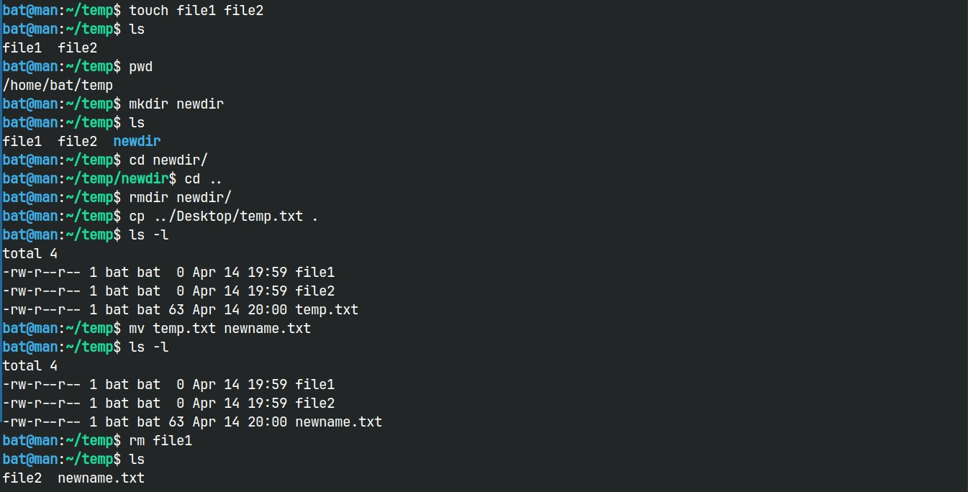**Ans1)** #Abhinav Jain 22SCSE1011721

|  |  |
| --- | --- |
| **Linux Commands** | **Functions** |
| **Is** | Displays information about files in the current directory. |
| **pwd** | Displays the current working directory. |
| **mkdir** | Creates a directory. |
| **cd** | Changes the working directory |
| **rmdir** | Removes empty directories from the directory lists. |
| **cp** | Moves files from one directory to another. |
| **mv** | Rename and Replace the files |
| **rm** | Delete files |

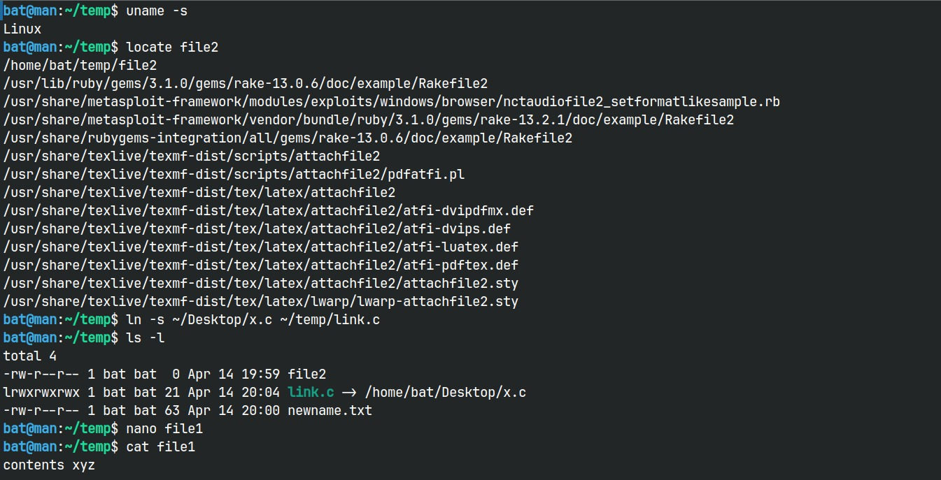

|  |  |
| --- | --- |
| **uname** | Command to get basic information about the OS |
| **locate** | Find a file in the database. |
| **touch** | Create empty files |
| **ln** | Create shortcuts to other files |
| **cat** | Display file contents on terminal |

|  |  |
| --- | --- |
| **clear** | Clear terminal |
| **ps** | Display the processes in terminal |
| **man** | Access manual for all Linux commands |
| **grep** | Search for a specific string in an output |
| **echo** | Display active processes on the terminal |
| **wget** | download files from the internet. |

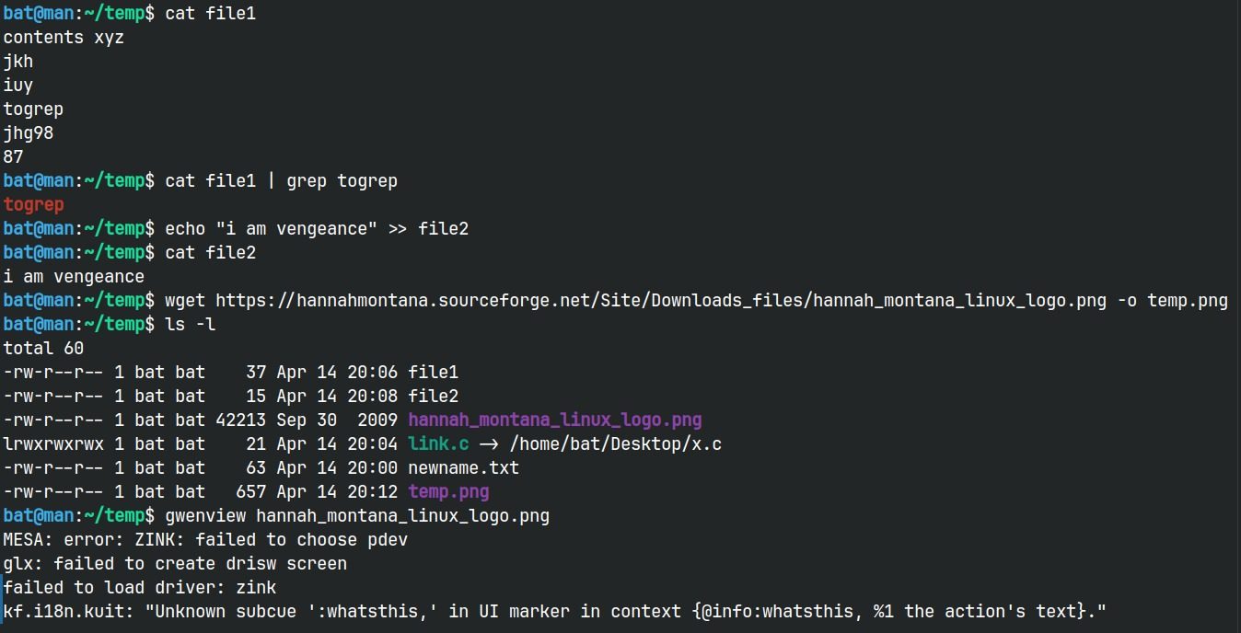

|  |  |
| --- | --- |
| **whoami** | Create or update passwords for existing users |
| **sort** | sort the file content |
| **cal** | View Calendar in terminal |
| **whereis** | View the exact location of any command typed after this command |
| **df** | Check the details of the file system |
| **wc** | Check the lines, word count, and characters in a file using different options |

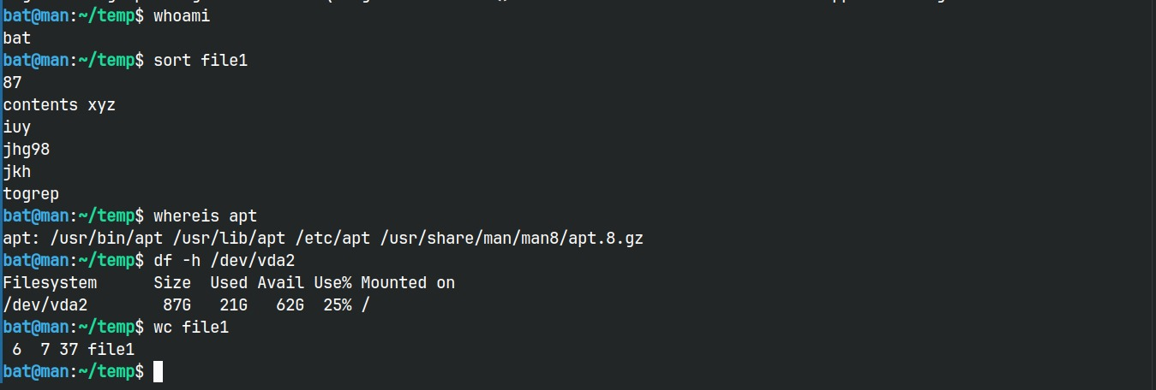

**Q2) Write a shell script to print arithmetic operations.**

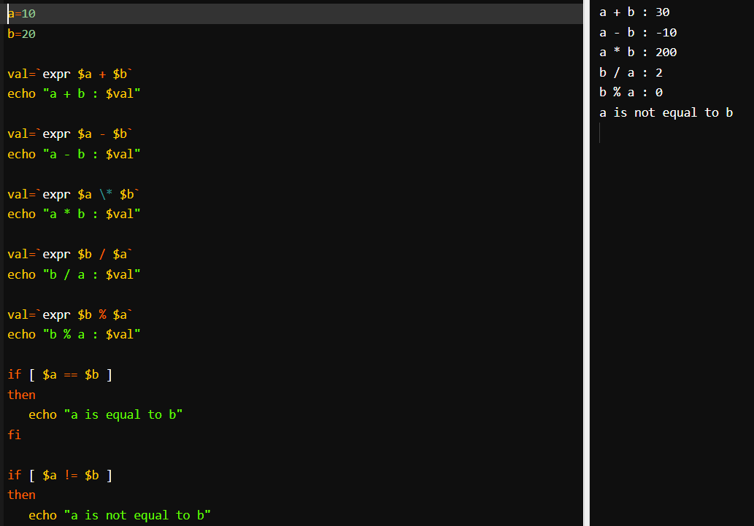**Ans2)** #Abhinav Jain 22SCSE1011721

**Q3) Write a shell script print largest among two numbers.**

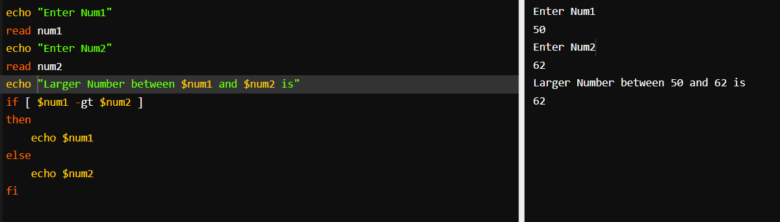**Ans3)** #Abhinav Jain 22SCSE1011721

**Q4. Write a shell script to print factorial of given number.**

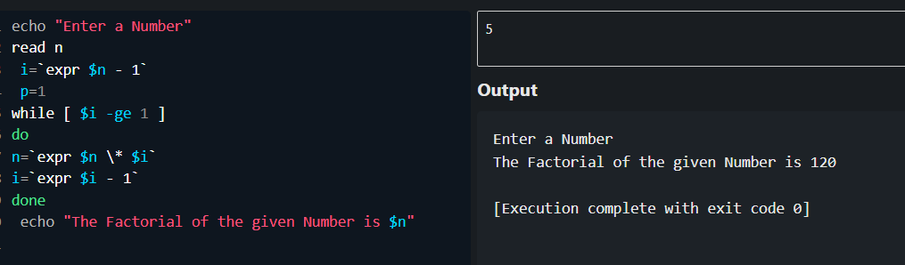**Ans4)** #Abhinav Jain 22SCSE1011721

**Q5) Write a shell script to check number is even or odd**

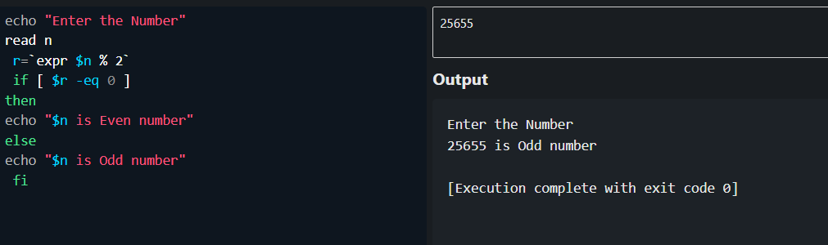**Ans5)** #Abhinav Jain 22SCSE1011721